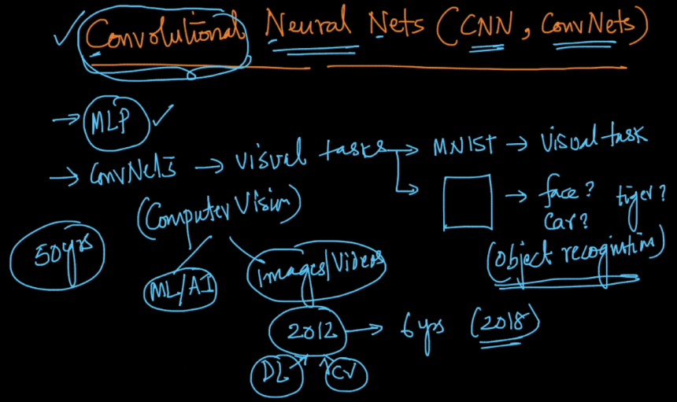

Biological experiments has performed on mammals in which it founds tha for particular thing few neurons gets activated as shown in image below.

In human brain there is separate layer which is responsible for identifying separate things like v1 is responsible for detecting motion, v3 for color and so on.

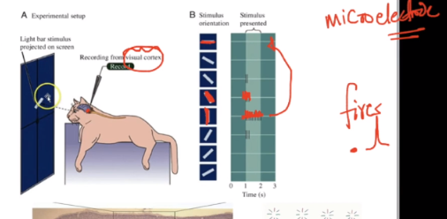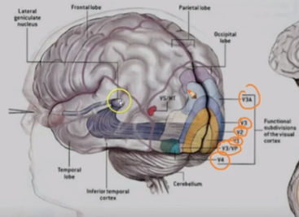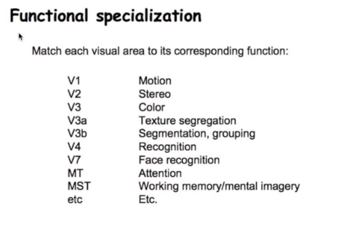

So key findings from real biological brain is:

1. Some neurons are fired or activated for different things, like some neuron fires when line is presented at specified angle
2. There is separate layer for each task like edge-detector, motion, depth, color, shapes, faces.

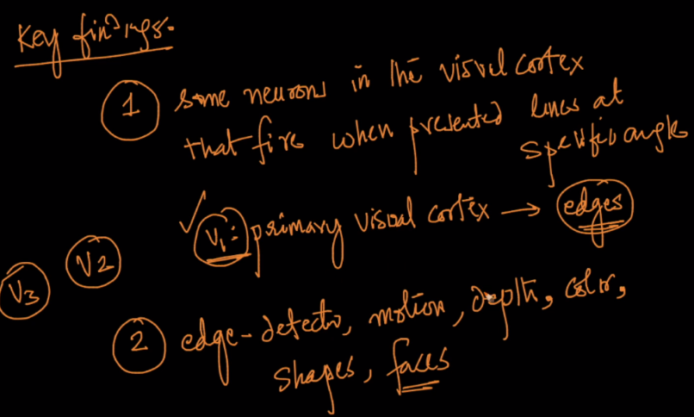

Below image shows how it’s similar to MLP:

* In first layer we detect edge.
* Then we find regions
* Then we find small objects
* Then we detect whole object like fish

This whole process is performed sequentially as we do in MLP

